Name: Rishika Soni
Roll no: 48
Section: A
Batch: A3
Practical No.4
Study and Implementation of
- Aggregate functions
- Group By & Having clause
- Order by clause

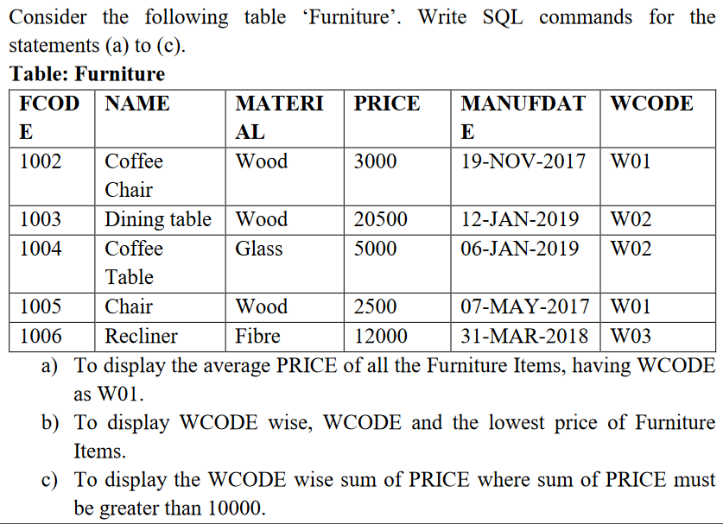
- Find the maximum, minimum, and total price.
select min(price) from furniture;
select max(price) from furniture;
select sum(price) from furniture;
- Find the total number of furniture.
select count(*) from furniture;
- List the total price for each material.
select material,sum(price)
from furniture
group by material ;
- Give maximum price for wood.
select max(price) from furniture where material='Wood';

5.Display the average price of each material.
select avg(price),material from furniture group by material;
- List fcode and the amount of all furniture in ascending order of price.
select fcode,price from furniture order by price ;
- List the materials having a sum of price more than 10000.
select material,sum(price) from furniture having sum(price)>10000 group by material;
- Give the name of furniture whose number of wcode is less than 2.
select name from furniture where wcode<'W02';
- Give the name of materials whose average price is greater than 15000.
select material,avg(price) from furniture having avg(price)>15000 group by material;
- Give the name of materials whose total price is less than 6000.
select material,sum(price) from furniture having sum(price)<6000 group by material;
11.Display the name of the furnitures in descending order of manufacturing date.
select name from furniture order by manudate desc;

